4 Network Strategies and Their Evaluation
In the dynamic field of deep learning, the design, optimization, and evaluation of neural networks play a critical role in achieving high-performance models. This chapter provides a comprehensive overview of essential strategies for building and assessing deep networks, focusing on architecture selection, activation functions, optimization methods, regularization techniques, and model evaluation metrics.
Key considerations in architecture design, such as layer configuration, feature scalability, and computational efficiency, guide the choice of network structures, while advancements like Neural Architecture Search (NAS) are automating the process. The selection of activation functions, such as ReLU, Sigmoid, and Tanh, is pivotal in determining a network’s learning capability, with alternatives like Leaky ReLU and Mish offering better gradient stability. Optimization methods, notably Stochastic Gradient Descent (SGD) and Adam, refine the learning process, with hybrid approaches like SWATS balancing convergence speed and generalization. Regularization techniques, such as Dropout and L2 weight decay, are crucial for controlling overfitting and enhancing model robustness. [73] To assess model performance, metrics like Mean Squared Error, R² score, accuracy, precision, and recall provide insights into predictive accuracy, while cross-validation techniques and early stopping help mitigate overfitting and improve generalization to unseen data. This chapter delves into these strategies, offering a holistic view of how networks are designed, trained, and evaluated to achieve optimal performance. [18]
4.1 Architecture selection and design criteria
The effectiveness of deep learning models is largely determined by their architectural design, traditionally guided by expert knowledge and manual tuning. However, the advent of Neural Architecture Search (NAS) has revolutionized this process by automating the selection and optimization of network structures. When evaluating or designing architectures, several key criteria must be considered to ensure efficiency, scalability, and generalization. [81]
And in this we will look further more into the Neural Network (NN), including the input, hidden, and output layers. The neurons in consecutive layers are fully connected. The input data is represented by {𝑥₁, 𝑥₂, …, 𝑥ₙ} and the output data by {𝑦₁, 𝑦₂, …, 𝑦ₘ}. The output data from each layer is represented as {ℎ₁(𝑙), ℎ₂(𝑙), …, ℎₙₗ(𝑙)}, where the weight and bias for each neuron are denoted as 𝑤ᵢᵢ(𝑙) and 𝑏ᵢᵢ(𝑙), respectively. The sigmoid and Swish activation functions are used to enhance the learning ability of the network. [19]
Additionally, Dropout is applied to prevent overfitting, and Batch Normalization is used to ensure stable training. The network is trained using the Stochastic Gradient Descent (SGD) algorithm. Finally, the NN parameters, including the number of layers, learning rate, dropout rate, and other settings, are presented in Table 4.1.
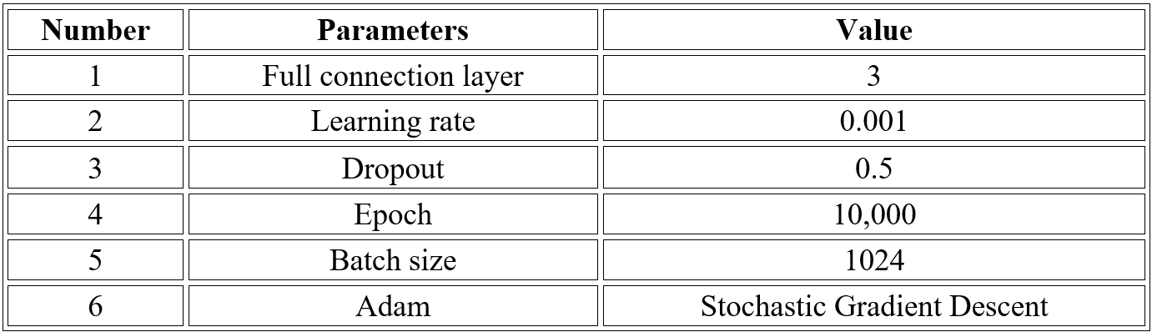
This table shows the key settings used to train the AI model, like a recipe for learning. The AI uses 3 layers to process information, learns slowly (0.001 rate) to avoid mistakes, and randomly "forgets" half its knowledge (0.5 dropout) during training to stay flexible. It practices on 1,024 examples at a time for 10,000 rounds using smart self-adjusting techniques to master tasks like image recognition efficiently. Based on research from "Learning Activation Functions to Improve Deep Neural Networks" (2019). [72]
1. Search Space Design
The search space defines the range of possible architectures, balancing flexibility and tractability. Common design choices include:
- Chain-structured networks or as also called sequential layers are used for simplicity and ease of implementation.
- Multi-branch topologies to enhance gradient flow and feature reuse.
- Cell-based architectures, where modular building blocks are stacked to improve scalability and transferability. [70]
A well-structured search space integrates prior knowledge while maintaining enough flexibility to foster innovation.
2. Performance-Driven Selection Strategies
Selecting an optimal architecture requires efficient navigation of the search space using various optimization strategies:
- Reinforcement Learning (RL): Uses policy-guided architecture generation to maximize validation accuracy.
- Evolutionary Algorithms: Employ mutation and selection techniques to refine architectures, often producing compact, high-performing models.
- Gradient-Based Methods: Utilize continuous relaxations to enable differentiable architecture search. [70]
An effective selection strategy must balance exploration and exploitation (refining known high-performing architectures).

3. Efficiency and Resource Constraints
Practical architecture selection involves evaluating trade-offs between:
- Accuracy vs. Computational Cost: Low-fidelity estimates or weight-sharing techniques accelerate evaluation but may introduce bias.
- Scalability: Hierarchical search spaces improve adaptability across different tasks.
- Hardware Compatibility: Architectures must align with deployment constraints, such as latency and memory limitations. [71]
4. Generalization and Robustness
Beyond task-specific performance, ideal architectures should:
- Transfer effectively to new datasets or domains.
- Resist overfitting through modularity and regularization.
- Adapt dynamically to multi-task or multi-objective settings, balancing accuracy with efficiency. [71]
5. The Rise of Neural Architecture Search (NAS)
Traditional neural network design has long depended on manual expertise, often leading to suboptimal or computationally expensive models such as ResNet and Inception. Neural Architecture Search (NAS) automates this process by algorithmically exploring architectures to optimize performance within predefined search spaces. Key NAS methods include:
- Reinforcement Learning (RL): Policies generate architectures, rewarded based on validation accuracy.
- Evolutionary Algorithms: Architectures evolve through mutation and selection, refining models iteratively.
- Random Search: Despite its simplicity, well-structured search spaces can yield surprisingly effective results. [19]
By eliminating the need for manual tuning, NAS accelerates model discovery and enhances efficiency across various deep learning applications.
6. Hybrid Approaches: Combining Automation with Human Expertise [82]
To balance efficiency with innovation, hybrid methods integrate NAS with manual design principles:
- Hierarchical Search Spaces: Inspired by human-designed modular motifs, enabling scalable and transferable architectures.
- Constrained Search: Limits exploration to plausible topologies (e.g., predefined macro-structures) to reduce computational cost.
- Warm-Start NAS: Initializes searches with high-performing handcrafted architectures (e.g., ResNet-based cells) to accelerate convergence. [18]
These approaches ensure that NAS benefits from human intuition while maintaining the advantages of automation.
7. Real-World Applications in Industry
NAS has been successfully deployed across various industries, addressing challenges related to scalability and resource efficiency:
- Computer Vision:
  - Image Classification: NAS-designed models outperform manually crafted architectures on benchmarks like CIFAR-10 and ImageNet.
  - Object Detection & Segmentation: AutoML systems optimize architectures for edge devices, balancing latency and accuracy.
- Natural Language Processing: Automated architecture discovery enhances transformer and RNN models for text-based applications.
- Hardware-Aware NAS: Custom architectures are tailored for TPUs, GPUs, and embedded systems, optimizing performance for specific hardware constraints. [81]
4.2 Activation Functions: ReLU, Sigmoid, Tanh
In artificial neural networks, activation functions play a crucial role in shaping the learning process and influencing overall performance. While many activation functions serve as universal approximators, their efficiency varies, prompting extensive research aimed at enhancing neural network capabilities. Despite their importance, conventional activation functions often encounter challenges such as saturation, the "dying neuron" issue, and the exploding or vanishing gradient problem.
To address these limitations, this work introduces two novel activation functions—absolute linear units and inverse polynomial linear units—each incorporating an adjustable parameter to fine-tune the gradient slope for improved optimization. This study also provides a detailed taxonomy of activation functions, systematically categorizing their characteristics and behavior. Comprehensive experiments are conducted across various deep neural architectures, considering network type and depth, to evaluate the effectiveness of these novel functions. Their performance is rigorously tested on image and text classification tasks using multiple public benchmark datasets, ensuring a thorough comparison with widely used activation functions. Results indicate that the proposed activation functions surpass many conventional ones in multiple benchmarks, with a statistical analysis across classification categories further confirming their robustness and superior accuracy.
Results indicate that the proposed activation functions surpass many conventional ones in multiple benchmarks. A statistical analysis across classification categories further confirms their robustness and superior accuracy, establishing them as promising alternatives in deep learning applications. [18]
1. Fundamental Activation Functions: Sigmoid, Tanh, and ReLU
Activation functions introduce non-linearity into neural networks, enabling them to learn complex patterns. Among the most widely used are the Rectified Linear Unit (ReLU), Logistic Sigmoid, and Hyperbolic Tangent (Tanh), each offering unique advantages and trade-offs. [77]
Traditional Non-linearities: Sigmoid and Tanh
Historically, Sigmoid and Tanh functions were foundational for introducing non-linearity.
- Sigmoid Function: The Sigmoid activation function maps input values to the range [0,1], making it useful for probabilistic interpretations in output layers. It is defined as:
$$σ\left(x\right)=1+e-x1​$$
While historically popular, Sigmoid suffers from vanishing gradients at extreme input values, which significantly slows down the training of deep networks due to saturation.
- Hyperbolic Tangent (Tanh) Function: The Tanh function transforms inputs into the range [−1,1], making it zero-centered, which can aid convergence compared to Sigmoid. It is given by:
$$\operatorname{Tanh}\left(x\right)=ex+e-xex-e-x​$$
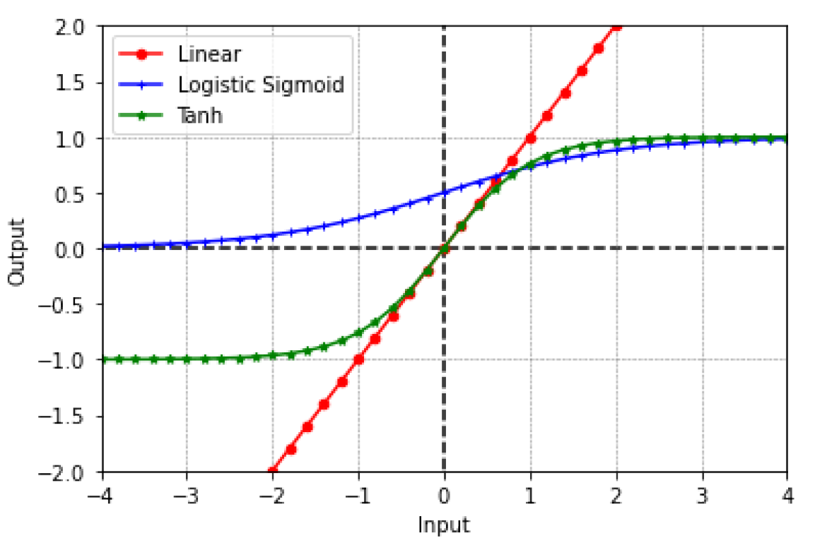
Tanh improves convergence over Sigmoid but still suffers from gradient saturation at large input values, similar to the Sigmoid function.

(See Fig 4.1 for an illustration of Linear, Logistic Sigmoid, and Tanh activation functions, adapted from Activation Functions in Deep Learning (2022) [18]).
2. The Modern Standard: Rectified Linear Unit (ReLU)
The Rectified Linear Unit (ReLU) is widely adopted in deep learning due to its computational efficiency and ability to avoid saturation for positive inputs. It is defined as:
$$ReLU\left(x\right)=\max\left(0,x\right)$$
Advantages of ReLU:
- Efficient Computation: ReLU involves no exponentiation, making it significantly faster to compute than Sigmoid or Tanh.
- Sparsity: By outputting zero for negative inputs, ReLU introduces sparsity in the network, potentially reducing activation redundancy and improving computational efficiency. [74]
Limitations of ReLU:
- Dying ReLU: Neurons can become permanently inactive if their input consistently falls into the negative range, leading to a gradient of zero. This means the neuron stops learning entirely.
- Unbounded Output: For positive inputs, ReLU's output is unbounded, which can sometimes lead to instability in very deep networks by causing large activation values. [74]

3. Hybrid and Adaptive Variants
To mitigate ReLU's shortcomings and address the limitations of traditional activation functions, several modified and adaptive variants have been introduced:
- Leaky ReLU (LReLU): This variant addresses the "dying ReLU" problem by allowing a small, non-zero gradient for negative inputs. It is defined as:
Leaky $ReLU(x)=x$​ if x>0 if and $eLU(x)=αx$ x≤0​
where α is a small positive constant. [18]
- Parametric ReLU (PReLU): An extension of Leaky ReLU, PReLU uses a learnable parameter α for negative inputs, allowing the network to adapt the slope during training.
- Scaled Tanh & SiLU (Sigmoid Linear Unit): These and other variants aim to combine the advantages of Sigmoid/Tanh (e.g., bounded outputs) while preserving efficient gradient flow and addressing saturation issues. [72]

4. Practical Considerations
- ReLU's Prevalence: ReLU is generally preferred for most deep learning applications due to its simplicity and effectiveness, offering a good balance between computational cost and performance.
- Context-Specific Use: Sigmoid and Tanh remain useful in specific contexts, such as binary classification (Sigmoid in the output layer) and recurrent neural networks (Tanh), but they require careful initialization to avoid vanishing gradients.
- Emerging Functions: The development of novel activation functions, including the absolute linear units and inverse polynomial linear units proposed in this work, continues to integrate properties of existing functions to overcome their limitations. While these new functions demonstrate promising results, their computational costs and ease of integration into existing frameworks often impact their widespread adoption. [18]
4.3 Optimization Methods: SGD, Adam
Despite their strong performance during early training, adaptive optimization methods such as Adam, Adagrad, and RMSprop often struggle to match the generalization ability of Stochastic Gradient Descent (SGD) in the later stages of training. While these methods accelerate convergence initially, they tend to be outperformed by SGD when it comes to final model performance. To address this, a hybrid approach has been explored—starting with an adaptive method and switching to SGD at the right moment. One such strategy, SWATS (Switching from Adam to SGD), introduces a simple mechanism that transitions from Adam to SGD based on a condition derived from the alignment of optimization steps with the gradient subspace. This switch adds minimal computational overhead and requires no additional hyper parameters. [73]
1. Stochastic Gradient Descent (SGD)
SGD is a fundamental optimization algorithm used to train deep neural networks by iteratively minimizing the loss function f(w).
The rule is given by:
$$wk=wk-1-ηk-1∇f\left(wk-1\right)w_{k}= w_{\left\{k-1\right\}}- η_{\left\{k-1\right\}∇f\left(w_{\left\{k-1\right\}}\right)}$$
where $ηk\backslash eta_{k}$ is the learning rate and $∇f\backslash nabla$ f represents the stochastic gradient. SGD is widely used due to its simplicity and theoretical guarantees, such as avoiding saddle points and its Bayesian interpretation. However, its uniform gradient scaling across all parameters can lead to slow convergence in ill-conditioned problems. [76]
Momentum-Based SGD (SGDM)
Momentum enhances SGD by incorporating a velocity term $vkv_{k}$, which helps smooth gradient updates:
$$wk=wk-1-ηk-1vkw_{k}= w_{\left\{k-1\right\}}- η_{\left\{k-1\right\}v_{k}}$$
where β∈[0,1)\beta \in [0,1) is the momentum coefficient. This technique accelerates convergence by reducing oscillations in the optimization trajectory.
2. Adaptive Methods: Adam
Adam (Adaptive Moment Estimation) improves upon SGD by adapting learning rates per parameter using estimates of gradient moments. The update rules are:
$$wk=wk-1-ηk-1mk-1vk-1+ϵw_{k}= w_{\left\{k-1\right\}}-η_{\left\{k-1\right\} }\frac{m_{\left\{k-1\right\}}}{\sqrt{\left\{v_{\left\{k-1\right\}}\right\}}+ ϵ}$$
where $β1,β2$ control exponential decay rates, and $ϵ$ epsilon is a small constant to prevent division by zero. Adam is particularly effective for sparse gradients and ill-scaled problems, but it may generalize worse than SGD in some cases due to non-uniform gradient scaling. [74]
3. Hybrid Approaches
To combine Adam’s rapid initial progress with SGD’s superior generalization, SWATS (Switching from Adam to SGD) automatically transitions from Adam to SGD:
- Learning rate estimation: Projects Adam’s step onto the gradient subspace to derive an SGD-compatible rate.
- Switch criterion: Triggers when the bias-corrected Adam rate stabilizes.
Empirical studies show that SWATS retains Adam’s early-stage efficiency while achieving SGD’s final performance. [74]
4. Practical Insights
- SGD/SGDM excels in generalization-critical tasks but requires careful learning rate tuning.
- Adam is robust to hyper parameters and ideal for early training phases.
- Adaptive methods offer trade-offs between convergence speed and generalization. [73]
4.4 Regularization: Dropout and L2 Regularization
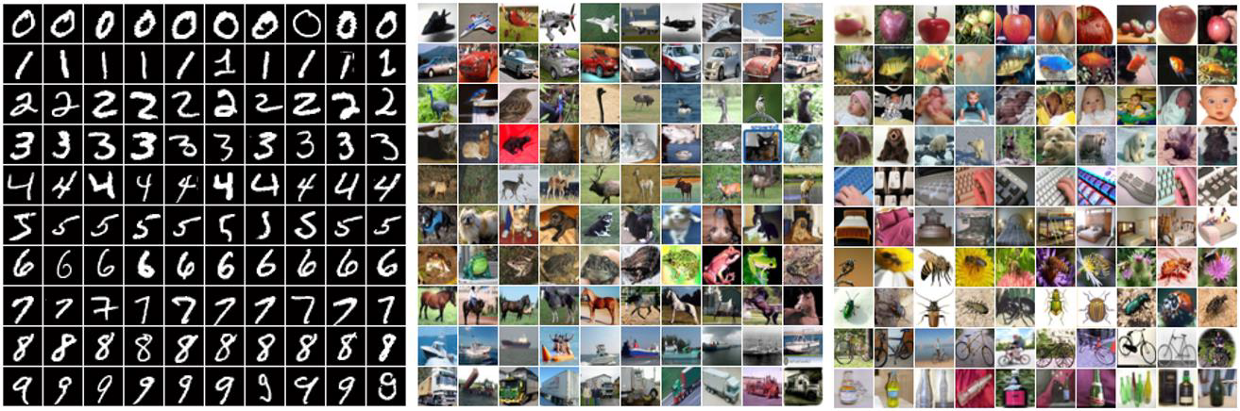
Regularization techniques are crucial for mitigating overfitting in deep neural networks, particularly when training data is limited. They enhance model generalization, especially when training on complex and high-dimensional data. This section explores two widely used methods: Dropout and L2 regularization, both of which significantly contribute to improving the generalization ability of neural networks, allowing them to perform well on unseen data. [78]

Fig 4.2: Sample images from the MNIST, CIFAR-10, and CIFAR-100 datasets.
Each row represents images from a distinct category. (Adapted from Towards Dropout Training for Convolutional Neural Networks (2015). [77])

1. Dropout: Stochastic Regularization
Dropout is a powerful regularization technique that mitigates overfitting by randomly deactivating a fraction of neurons during training. This prevents co-adaptation among features and effectively trains an ensemble of subnetworks.
- Mechanism: During each training iteration, Dropout randomly sets a fraction of neuron activations to zero.
- Effect: This stochastic deactivation forces the model to learn more robust features and prevents it from becoming overly reliant on any single neuron.
- Application: Dropout is particularly useful in large neural networks where the risk of overfitting is high due to an excess of parameters.
- Training Phase: For each mini-batch, neurons are dropped stochastically, and the activations of the remaining neurons are scaled by 1/p (where p is the retaining probability) to maintain the expected magnitudes of the network's output.
- Inference Phase: All neurons remain active, but their weights are scaled by p (or activations by 1/p) to approximate model averaging, which is characteristic of an ensemble. [78]
2. Variants of Dropout:
- Max-Pooling Dropout: This variant applies dropout to pooling regions, which can be interpreted as sampling from a multinomial distribution.
- Probabilistic Weighted Pooling: This method replaces deterministic max-pooling at test time with a weighted sum of activations, often leading to improved generalization.
Empirical studies show that Dropout significantly reduces overfitting in fully connected layers. However, its effectiveness in convolutional layers can be limited due to inherent parameter sharing and spatial locality. [19]

3. L2 Regularization: Weight Decay
L2 regularization, also known as weight decay, is a widely used regularization technique that penalizes large weights in a neural network.
- Mechanism: L2 regularization adds a term to the loss function based on the squared magnitude of the weights. The modified loss function is given by:
Lossnew​=Lossoriginal​+λi∑​wi2​
where λ (lambda) is a hyperparameter that controls the strength of the penalty, and wi​ represents the individual weights in the network.
- Effect: This penalty encourages the model to learn smoother, smaller weights, thereby reducing model complexity and improving generalization. By discouraging large weights, L2 regularization prevents the model from fitting noise in the training data, leading to more stable models. [19]

4. Comparative Analysis and Hybrid Approach
Dropout and L2 regularization are complementary techniques for combating overfitting, and their combined use often yields superior performance.
- Dropout's Strengths: Dropout excels in high-capacity networks, achieving state-of-the-art results on benchmarks like MNIST and CIFAR-10, primarily by preventing feature co-adaptation and creating an ensemble effect.
- L2 Regularization's Strengths: L2 regularization is simpler to implement and computationally cheaper. While less effective alone for very deep networks, it provides a stable and interpretable penalty by constraining weight magnitudes.
- Hybrid Approach: Combining both methods often leads to superior performance. L2 regularization constrains weight magnitudes, while Dropout prevents feature co-adaptation, creating a robust and generalized model. [18]

5. Practical Considerations
Several practical aspects should be considered when implementing Dropout and L2 regularization:
- Layer-Specific Application: Dropout is most effective in fully connected layers, whereas convolutional layers benefit less due to their inherent spatial locality and parameter sharing.
- Hyperparameter Tuning: The retaining probability p for Dropout and the regularization strength λ for L2 regularization are crucial hyperparameters that must be carefully optimized for the best results through techniques like cross-validation.
- Computational Overhead: While Dropout does increase training time due to the stochastic nature of its operation, it does not significantly affect inference cost once the model is trained. [77]
Conclusion
In summary, both Dropout and L2 regularization are integral techniques for improving the generalization of deep neural networks, particularly when faced with the challenge of overfitting. Dropout introduces stochasticity into the training process, forcing the model to learn more robust and diverse features, while L2 regularization imposes a penalty on large weights, ensuring smoother and more stable models. Though each technique has its strengths, their combined use offers a powerful strategy to enhance model performance. As with any regularization method, careful hyperparameter tuning is crucial to achieve optimal results, and understanding the nuances of their application—such as the suitability of Dropout for fully connected layers versus its limited effectiveness in convolutional layers—can guide practitioners toward better model design choices. Moving forward, exploring hybrid approaches, adjusting for specific datasets, and testing these methods across various network architectures will be essential in refining the balance between model complexity and performance.

